**BYAGARI PAVAN PBL ID: J_251890123**

**Java Fundamentals:**

**Mini Projects:**

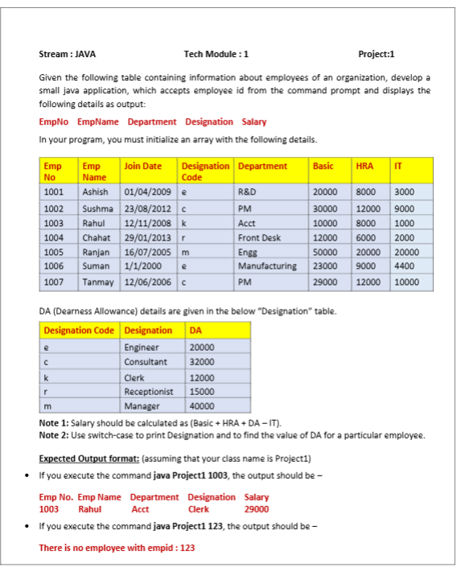

**Code:**

import java.util.*;

class Employee {

int empNo;

String empName;

String joinDate;

char desigCode;

String dept;

int basic;

int hra;

int it;

Employee(int empNo, String empName, String joinDate, char desigCode, String dept, int basic, int hra, int it) {

this.empNo = empNo;

this.empName = empName;

this.joinDate = joinDate;

this.desigCode = desigCode;

this.dept = dept;

this.basic = basic;

this.hra = hra;

this.it = it;

}

}

public class Project1 {

public static void main(String[] args) {

// Employee data initialization

Employee[] employees = {

new Employee(1001, "Ashish", "01/04/2009", 'e', "R&D", 20000, 8000, 3000),

new Employee(1002, "Sushma", "23/08/2012", 'c', "PM", 30000, 12000, 9000),

new Employee(1003, "Rahul", "12/11/2008", 'k', "Acct", 10000, 8000, 1000),

new Employee(1004, "Chahat", "29/01/2013", 'r', "Front Desk", 12000, 6000, 2000),

new Employee(1005, "Ranjan", "16/07/2005", 'm', "Engg", 50000, 20000, 20000),

new Employee(1006, "Suman", "01/01/2000", 'e', "Manufacturing", 23000, 9000, 4400),

new Employee(1007, "Tanmay", "12/06/2006", 'c', "PM", 29000, 12000, 10000)

};

// DA details using switch

Map<Character, String> designationMap = new HashMap<>();

designationMap.put('e', "Engineer");

designationMap.put('c', "Consultant");

designationMap.put('k', "Clerk");

designationMap.put('r', "Receptionist");

designationMap.put('m', "Manager");

Map<Character, Integer> daMap = new HashMap<>();

daMap.put('e', 20000);

daMap.put('c', 32000);

daMap.put('k', 12000);

daMap.put('r', 15000);

daMap.put('m', 40000);

// Check command-line argument

if (args.length == 0) {

System.out.println("Please provide Employee ID");

return;

}

int empId = Integer.parseInt(args[0]);

boolean found = false;

// Search employee

for (Employee emp : employees) {

if (emp.empNo == empId) {

found = true;

String designation = designationMap.get(emp.desigCode);

int da = daMap.get(emp.desigCode);

int salary = emp.basic + emp.hra + da - emp.it;

System.out.println("Emp No.\tEmp Name\tDepartment\tDesignation\tSalary");

System.out.println(emp.empNo + "\t" + emp.empName + "\t\t" + emp.dept + "\t\t" + designation + "\t" + salary);

break;

}

}

if (!found) {

System.out.println("There is no employee with empid : " + empId);

}

}

}

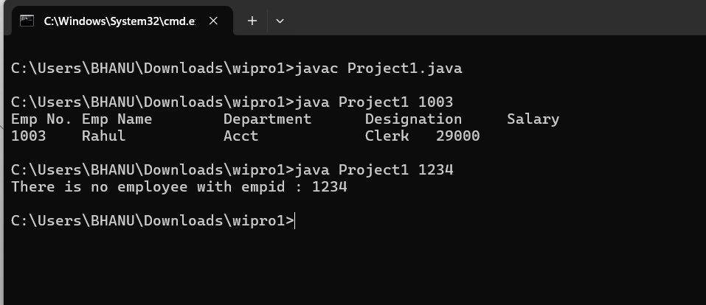**Compile & Run:-**